**IT24102821 - PS Lab 08**

**Question 01**

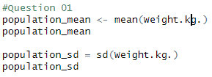

**Question 02**

**Question 03**

